Ponddy for Schools Questionnaire

In order to better assist you with Chinese curriculum design, please provide us with answers to the questions below to the best of your knowledge. After completing the questionnaire, please send it as an attachment to [***support@ponddy-edu.com***](mailto:support@ponddy-edu.com) and include “**Ponddy for Schools Inquiry**” in subject.

1. Contact information (name, phone number and email address)?
2. Name of your organization? What School Districts/State are you in?
3. What is your annual budget allocation for the Chinese language program?
4. What services are you interested in?
   1. Program Design
   2. Curriculum Design
   3. Online Instruction
   4. Teaching tech support
   5. Other _____________
5. How many students are expected for this course/program?
6. What is the expected size of each class (if more than one)?
7. What is the expected student age range for this course/program?
8. What is the targeted entry of Chinese proficiency levels for your program? You may use this chart to specify.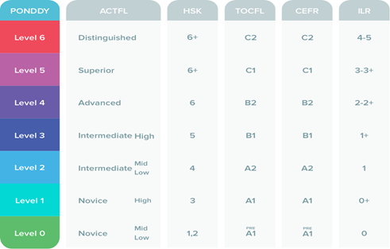
9. Would students be expected to take any Chinese proficiency test immediately after completion of this course/program? If so, please list which test(s).
10. Would the program be taught in simplified, traditional Chinese or both?
11. What is the expected workload for this course/program?
    1. How many hours of class are expected each week?
    2. How many hours of homework are expected each week?

1. Please briefly describe the learning goals and/or expected outcomes for this course/program.